WAF With wafw00f

Wafwoof -l
List the number of the firewall it can able able to check.
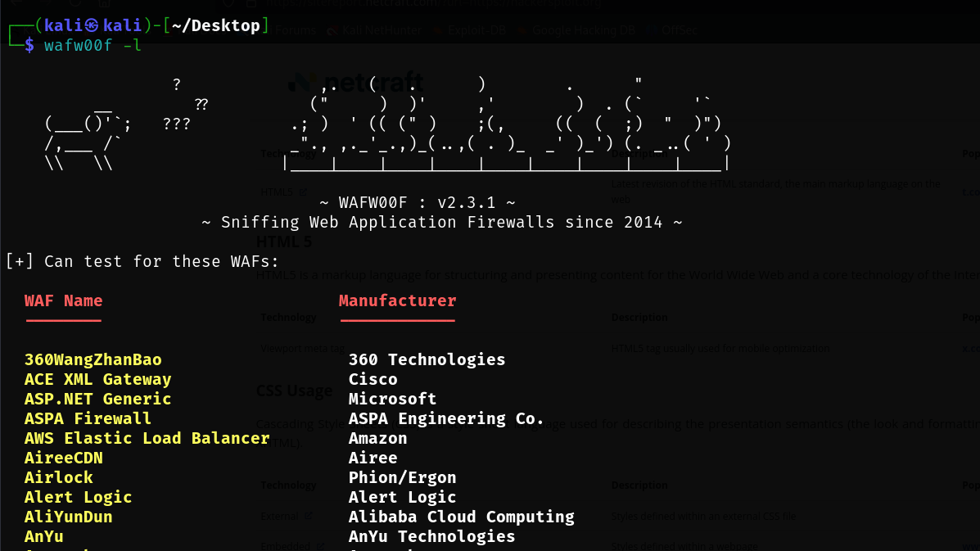

Wafw00f https://hackersploit.org
To the the firewall is installed or not and which firewall is installed.
